**SWE 325 Software Construction**

**[The Pyramid]**

**Team Members**

Tom Rose

DeAndre Chilton Jr.

# 1. Problem

* Our goal for this project was to create a moderately complex, test-based game using Python.

# 2. Solution

* Using Visual Studio Code and Github Desktop, we were able to plan and construct a game that includes 10 different rooms, each bringing something new to the player.

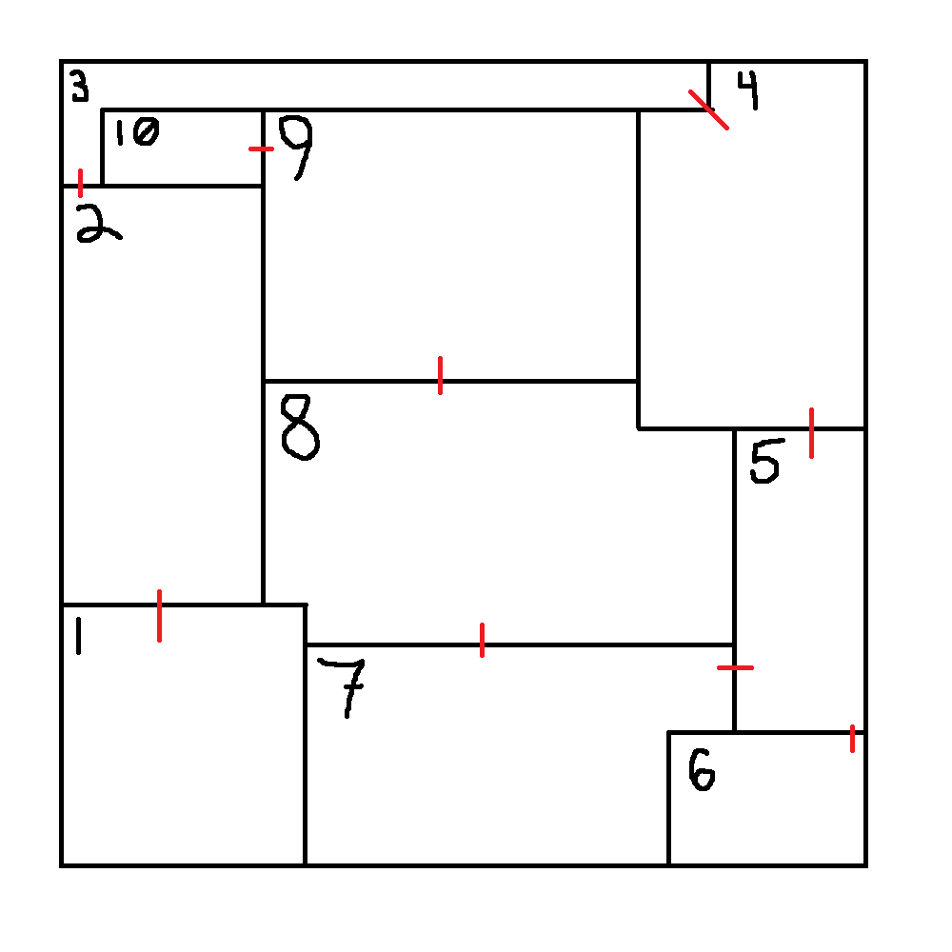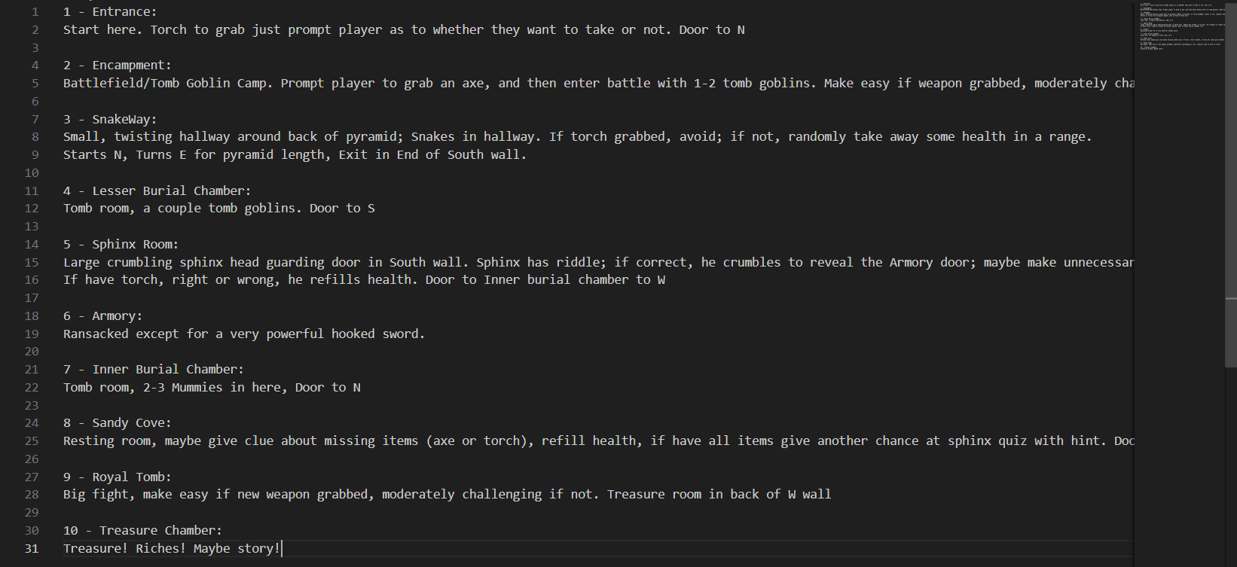

# 3. Demo

* <https://www.youtube.com/watch?v=A5VvTluqp0A>

# 4. Lessons Learned

* It would’ve been to our benefit to form a project architecture before beginning to code.

# 5. Issues/Bugs Known

* In our testing, we found that our test cases wouldn’t yield any results (pass or fail) when running the test file code. The reason for this is something we haven’t been able to attribute to one specific thing, however this issue doesn’t break any of the code’s functionality.

# 6. Future Versions

* Troubleshooting bugs, such as an issue in the snakeway that could be resolved by separating the functionality of checking for torch and capturing movement, and an issue that lets a player bounce back between the sphinx and the sandy cove, failing and unlocking the riddle.

# 7. References

* https://www.doxygen.nl/manual/docblocks.html
* <https://en.wikipedia.org/wiki/Isis>